Inserting the time series database into DynamoDB using AWS IoT Rule

|  |  |
| --- | --- |
| Title | Inserting the time series database into DynamoDB using AWS IoT Rule |
| By | Meenakshi Murugappan |
| Student Id: | L00156569 |

# Summary

This document describes inserting the time series data into DynamoDB using Rules in the AWS IoT core services

It describes the following tasks:

1. Create a DynamoDB.
2. Create an IAM policy to insert data into DynamoDB
3. Create a rule to subscribe to the topic from devices to insert data into DynamoDB

Contents

Summary 1

Resources and Prerequisites 3

Introduction 3

Steps 4

Problems Faced 6

Conclusion 7

References 7

# Resources and Prerequisites

1. Valid AWS credentials to sign into the AWS console to access the IoT core services
2. Valid IBM cloud account to install the node-red app.

# Introduction

This document provides the steps to insert the data into a DynamoDB to store the device's information as time series data, which can be used to visualize the data and use the machine learning algorithm to visualize the business and used to analyze predictive maintenance of the devices. The steps to achieve the highlighted section in the below diagram for AWS IoT time series databases have been described in this document.

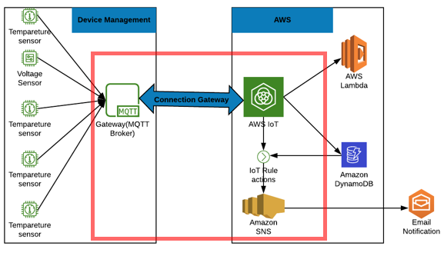

**Figure 1: Inserting the time series database into DynamoDB using AWS IoT Rule**

# Steps

1. Login to AWS Console and navigate to IoT core service to create a rule.

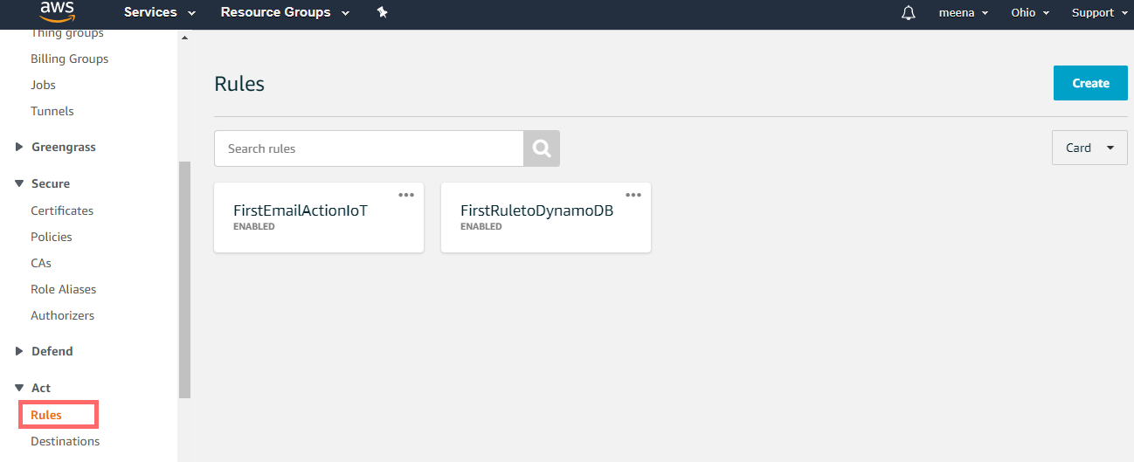

1. Click “Create” rule button at the top, Provide the name and description.

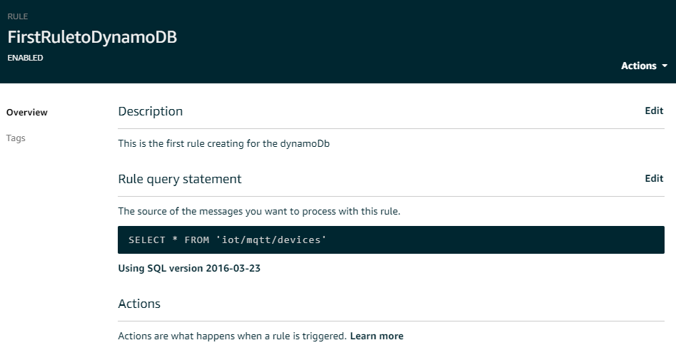

1. Add the rule query statement to subscribe to the topic published from the device sensor to insert the data into DynamoDB. Refer to this link [[3]](https://docs.aws.amazon.com/iot/latest/developerguide/iot-sql-reference.html?icmpid=docs_iot_console) to understand in detail of Rule query statement.

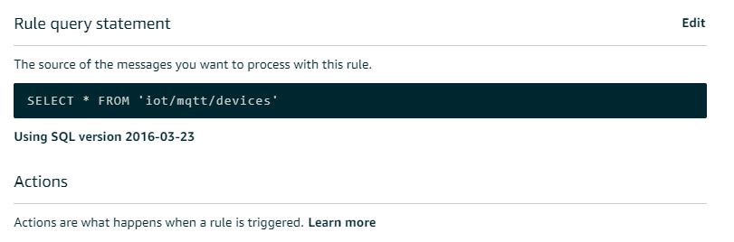

1. Create an action to insert a message into a DynamoDB table.

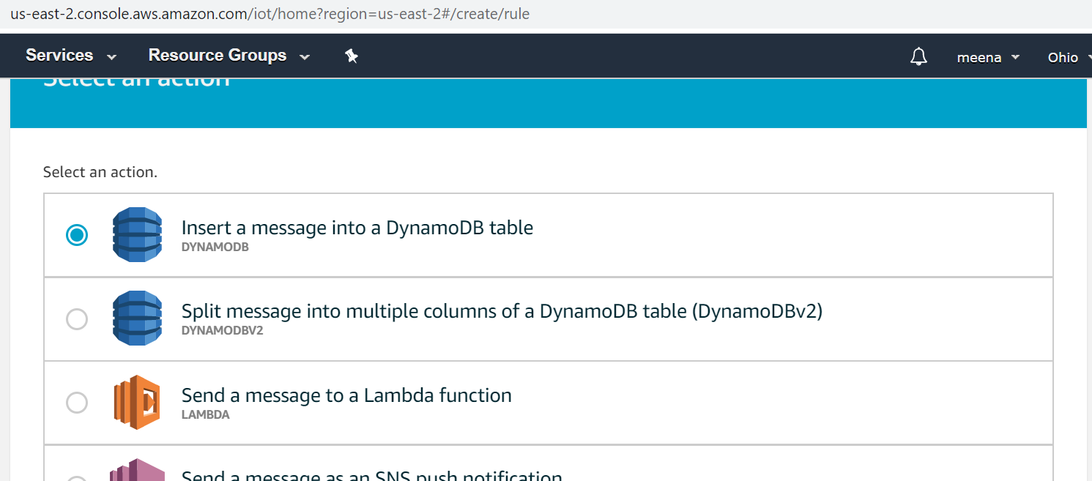

1. A database can be created or the created database to store the time series database.

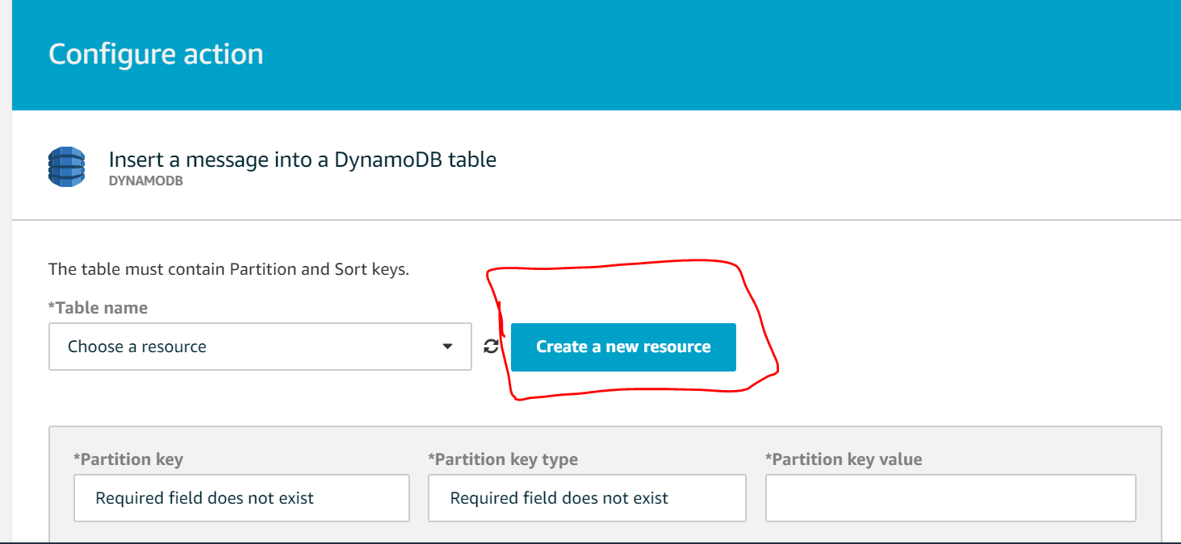

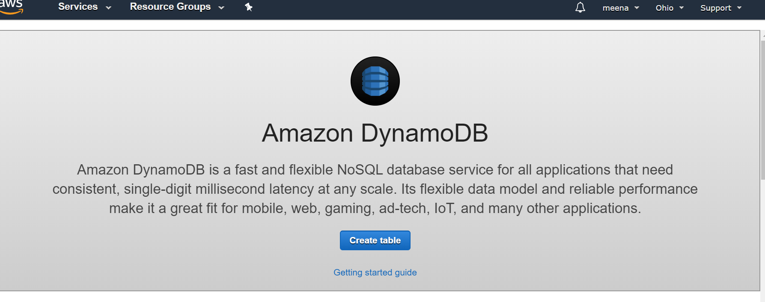

1. DynamoDB is a no SQL database, where the primary key is the DeviceId and sort key is the Timestamp.

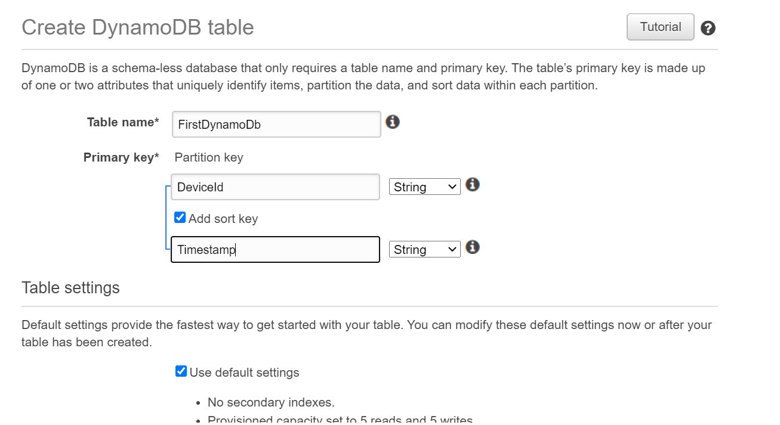

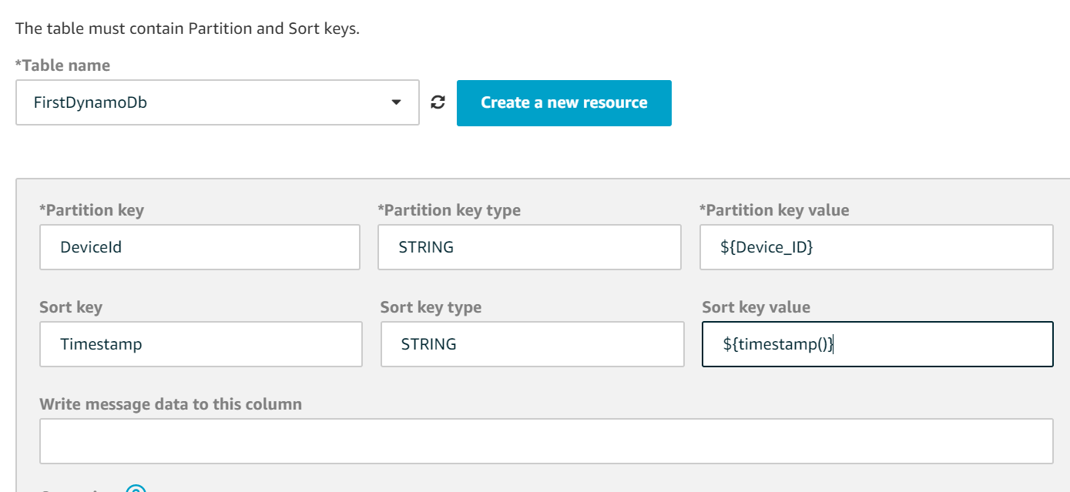

1. To interact with IoT core services and DynamoDB new IAM policy must be created considering the security guidelines from AWS.

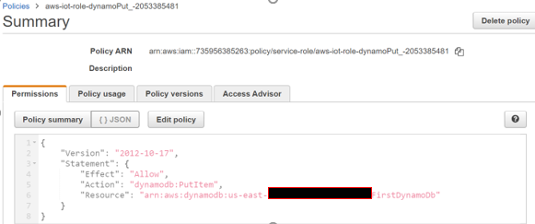

1. Attach the policy role with DynamoDB to insert the data by subscribing to the topic AWS IoT core devices.

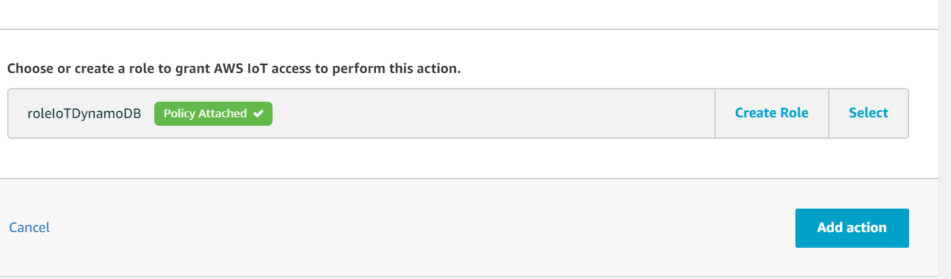

1. Using MQTT test client to publish the topic “IoT/mqtt/devices” using the below JSON.

{

Device_Id : “DeviceId1”,

Temp:”45”

}

1. Published the same topic using MQTTfx client, Refer to the “Integration of MQTTfx client to AWS IoT Console” for more details.

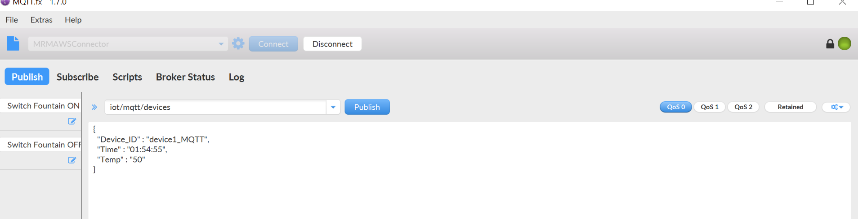

1. Verified the DynamoDB database, to see the values published using MQTTfx client and test client in AWS IoT core.

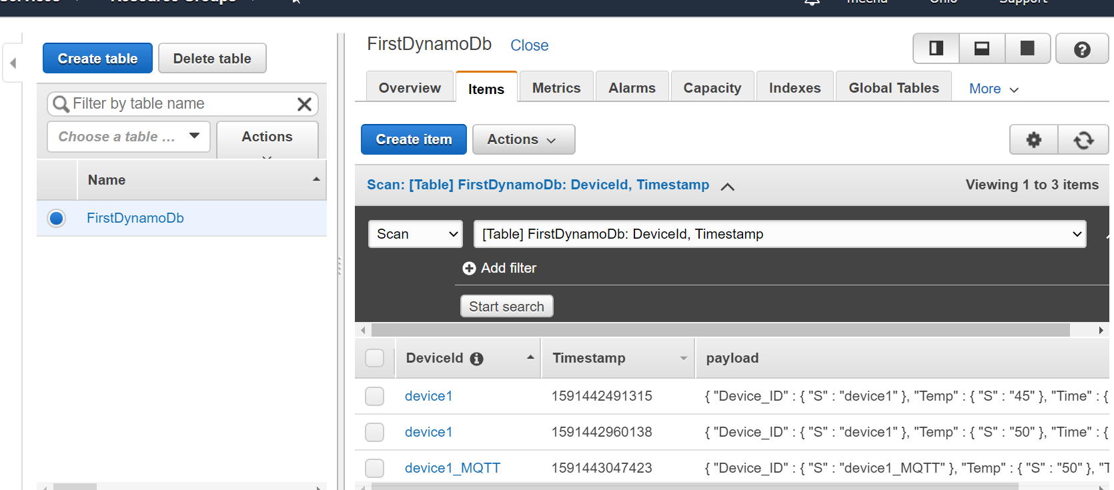

# Problems Faced

1. Ensure the IAM policy is attached to the IoT core to insert the data into DynamoDB.

# Conclusion

The purpose of the above exercise is to understand and store the time series data into DynamoDB using IoT rules action. AWS MQTT Test client and MQTTfx client are used for publishing the message and store into DynamoDB.

# References

[1] Creating a rule with a DynamoDB action, <https://docs.aws.amazon.com/iot/latest/developerguide/iot-ddb-rule.html>, 16-June-2020.

[2] AWS IoT Core, <https://aws.amazon.com/iot-core/>, 01-June-2020.

[3] AWS IoT SQL reference, <https://docs.aws.amazon.com/iot/latest/developerguide/iot-sql-reference.html?icmpid=docs_iot_console>, 18-June-2020

[4] DynamoDB, <https://aws.amazon.com/dynamodb/>, 18-June-2020